OBJECTIVE
Objective Questions:
- Are there any tables with duplicate or missing null values? If so, how would you handle them?
Ans- OBSERVATION :
QUERY:
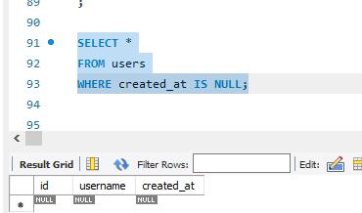
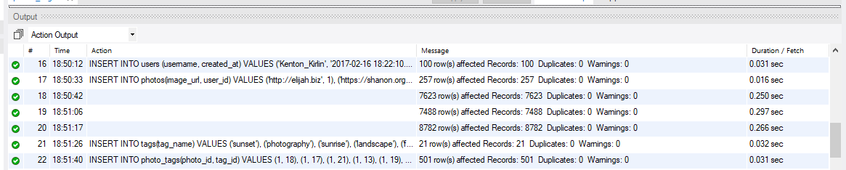
- No duplicate values found in the tables, refer below snap.

- What is the distribution of user activity levels (e.g., number of posts, likes, comments) across the user base?

Ans- OBSERVATION :
QUERY:
SELECT
u.id AS user_id,
u.username,
COUNT(DISTINCT p.id) AS post_count,
COUNT(DISTINCT l.photo_id) AS like_count,
COUNT(DISTINCT c.id) AS comment_count
FROM users u
LEFT JOIN photos p
ON u.id = p.user_id
LEFT JOIN likes l
ON u.id = l.user_id
LEFT JOIN comments c
ON u.id = c.user_id
GROUP BY u.id, u.username;

the distribution of user activity by aggregating the number of posts, likes, and comments for each user using LEFT JOINs across activity tables. This approach shows how engagement is spread across the entire user base, including inactive users.
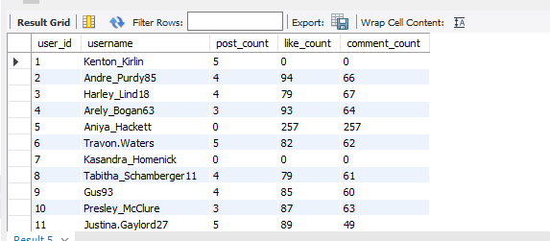

- Calculate the average number of tags per post (photo_tags and photos tables).
Ans- OBSERVATION :

To calculate the average number of tags per post, we need to:

Count how many tags each photo has (from photo_tags)

Take the average of those counts across photos:

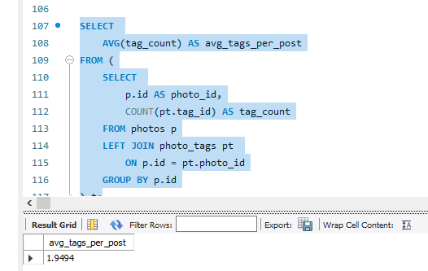

- Identify the top users with the highest engagement rates (likes, comments) on their posts and rank them.

Ans- OBSERVATION :
Users with the highest engagement rates are those whose posts receive a large number of likes and comments relative to the number of posts they share.
These top-ranked users act as high-impact contributors, generating strong audience interaction even with fewer posts. This indicates higher content quality or stronger follower interest compared to users who post frequently but receive lower engagement per post.
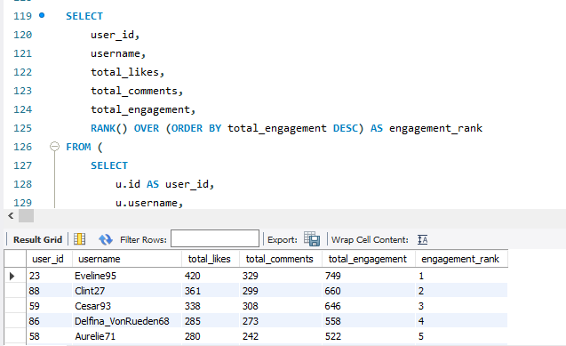

- Which users have the highest number of followers and followings?
Ans- OBSERVATION:
Users with the highest number of followers represent the most influential accounts on the platform, as they attract the maximum audience interest.
Users with the highest number of followings are the most active in exploring and engaging with other users’ content.
Together, this highlights a clear distinction between influencers (high followers) and active participants (high followings) within the user base
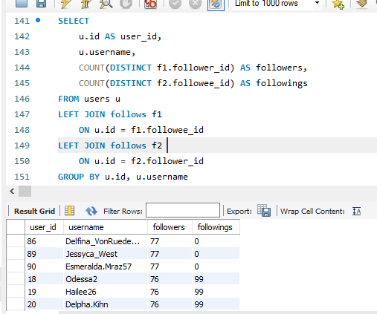

- Calculate the average engagement rate (likes, comments) per post for each user.
Ans- OBSERVATION:
The average engagement rate per post shows how effectively each user’s content interacts with the audience.
Users with a higher average engagement rate receive more likes and comments per post, indicating stronger audience interest, while users with lower rates may need to improve content quality or posting strategy.

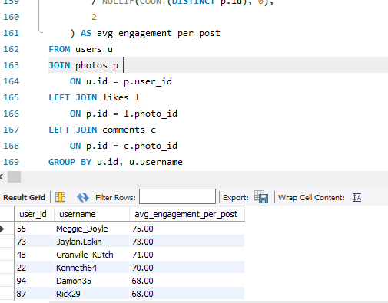

- Get the list of users who have never liked any post (users and likes tables).
Ans- OBSERVATION:
These users are inactive in terms of liking content. They may consume content passively or are new users who have not interacted yet. Identifying them helps in targeting for engagement campaigns or understanding passive user behavior.
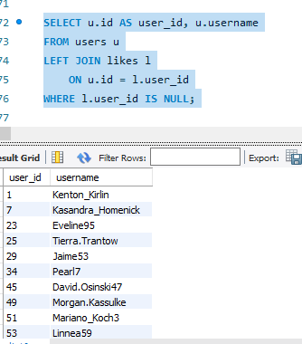
- how can you leverage user-generated content (posts, hashtags, photo tags) to create more personalized and engaging ad campaigns?
Ans- OBSERVATION:
QUERY:
SELECT
a). count tag_usage per users
u.id AS user_id,
u.username,
t.tag_name,
COUNT(pt.photo_id) AS tag_usage_count
FROM users u
JOIN photos p
ON u.id = p.user_id
JOIN photo_tags pt
ON p.id = pt.photo_id
JOIN tags t
ON pt.tag_id = t.id
GROUP BY u.id, u.username, t.tag_name
ORDER BY u.id, tag_usage_count DESC;

b). Top user avg engagement rate
SELECT
u.username,
ROUND(
(COUNT(DISTINCT l.user_id, l.photo_id)
+ COUNT(DISTINCT c.id))
/ NULLIF(COUNT(DISTINCT p.id), 0), 2
) AS avg_engagement_per_post
FROM ig_clone.users u
LEFT JOIN ig_clone.photos p ON u.id = p.user_id
LEFT JOIN ig_clone.likes l ON p.id = l.photo_id
LEFT JOIN ig_clone.comments c ON p.id = c.photo_id
GROUP BY u.username
HAVING COUNT(DISTINCT p.id) > 0
ORDER BY avg_engagement_per_post DESC
LIMIT 10;
CHART:
a).

b). CHART

User-generated content like posts, hashtags, and photo tags reveals user interests, preferences, and trending topics. Leveraging this data helps create targeted and personalized ad campaigns, increasing engagement and conversion rates.
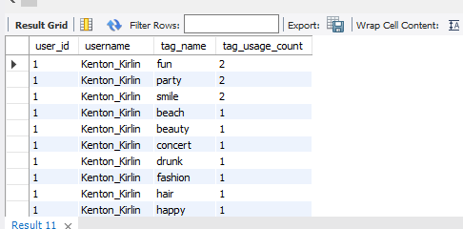
b).
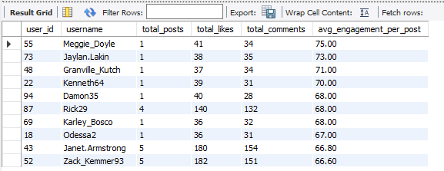

- Are there any correlations between user activity levels and specific content types (e.g., photos, videos, reels)? How can this information guide content creation and curation strategies?
OBSERVATION:
QUERY:
SELECT
t.tag_name AS content_topic,
COUNT(DISTINCT p.id) AS total_posts,
COUNT(DISTINCT l.user_id, l.photo_id) AS total_likes,
COUNT(DISTINCT c.id) AS total_comments,
ROUND(
(COUNT(DISTINCT l.user_id, l.photo_id)
+ COUNT(DISTINCT c.id))
/ NULLIF(COUNT(DISTINCT p.id), 0), 2
) AS avg_engagement_per_post
FROM ig_clone.tags t
JOIN ig_clone.photo_tags pt ON t.id = pt.tag_id
JOIN ig_clone.photos p ON pt.photo_id = p.id
LEFT JOIN ig_clone.likes l ON p.id = l.photo_id
LEFT JOIN ig_clone.comments c ON p.id = c.photo_id
GROUP BY t.tag_name
HAVING total_posts > 5
ORDER BY avg_engagement_per_post DESC;

Since the dataset does not explicitly distinguish between content types such as videos or reels, hashtags were used as a proxy to represent different content themes. By analyzing average likes and comments per post across hashtags, clear differences in engagement levels were observed, indicating a correlation between content topics and user activity. These insights can guide content creation and curation by prioritizing high-engagement themes to improve reach and interaction.

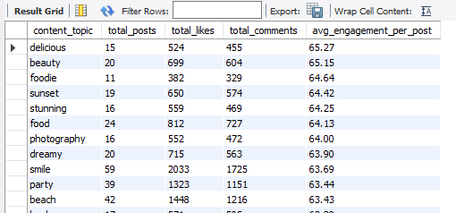
CHART:

- Calculate the total number of likes, comments, and photo tags for each user.
Ans- OBSERVATION:
QUERY:
SELECT
u.id AS user_id,
u.username,
COUNT(DISTINCT l.user_id, l.photo_id) AS total_likes,
COUNT(DISTINCT c.id) AS total_comments,
COUNT(DISTINCT pt.tag_id, pt.photo_id) AS total_photo_tags
FROM users u
LEFT JOIN photos p ON u.id = p.user_id
LEFT JOIN likes l ON p.id = l.photo_id
LEFT JOIN comments c ON p.id = c.photo_id
LEFT JOIN photo_tags pt ON p.id = pt.photo_id
GROUP BY u.id, u.username
ORDER BY total_likes DESC, total_comments DESC;

This shows the overall engagement and tagging activity per user. Users with higher numbers are more active in creating content, receiving engagement, and tagging their posts, reflecting strong participation on the platform.
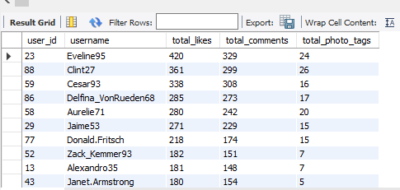

- Rank users based on their total engagement (likes, comments, shares) over a month.
Ans- OBSERVATION:
QUERY:
SELECT
user_id,
username,
total_likes,
total_comments,
(total_likes + total_comments) AS total_engagement,
RANK() OVER (ORDER BY (total_likes + total_comments) DESC) AS engagement_rank
FROM (
SELECT
u.id AS user_id,
u.username,
COUNT(DISTINCT l.user_id, l.photo_id) AS total_likes,
COUNT(DISTINCT c.id) AS total_comments
FROM users u
JOIN photos p ON u.id = p.user_id
LEFT JOIN likes l ON p.id = l.photo_id AND l.created_at >= DATE_SUB(CURDATE(), INTERVAL 1 MONTH)
LEFT JOIN comments c ON p.id = c.photo_id AND c.created_at >= DATE_SUB(CURDATE(), INTERVAL 1 MONTH)
WHERE p.created_dat >= DATE_SUB(CURDATE(), INTERVAL 1 MONTH)
GROUP BY u.id, u.username
) t
ORDER BY total_engagement DESC;

Ranking users by total engagement over a month highlights the most active and influential users within that period. Users with higher engagement are driving platform interaction and can be targeted for promotions, rewards, or featured content.
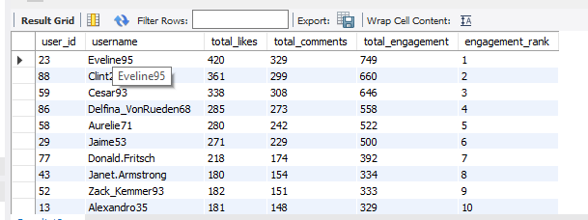

- Retrieve the hashtags that have been used in posts with the highest average number of likes. Use a CTE to calculate the average likes for each hashtag first.
Ans- OBSERVATION:
QUERY:
WITH hashtag_avg_likes AS (
SELECT
t.tag_name,
AVG(likes_count) AS avg_likes
FROM (
SELECT
p.id AS photo_id,
pt.tag_id,
COUNT(l.user_id) AS likes_count
FROM photos p
LEFT JOIN likes l ON p.id = l.photo_id
LEFT JOIN photo_tags pt ON p.id = pt.photo_id
GROUP BY p.id, pt.tag_id
) photo_likes
JOIN tags t ON photo_likes.tag_id = t.id
GROUP BY t.tag_name
)
SELECT tag_name, avg_likes
FROM hashtag_avg_likes
ORDER BY avg_likes DESC
LIMIT 10;

Hashtags used in posts with the highest average likes indicate trending or highly engaging content topics. These hashtags can guide content strategy, trending campaigns, or ad targeting to maximize user engagement.
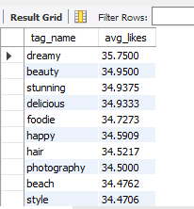

- Retrieve the users who have started following someone after being followed by that person.
Ans- OBSERVATION:
QUERY:

SELECT
f1.follower_id AS user_id,
u.username AS user_name,
f1.followee_id AS followed_user_id,
u2.username AS followed_user_name
FROM follows f1
JOIN follows f2
ON f1.follower_id = f2.followee_id
AND f1.followee_id = f2.follower_id
JOIN users u ON f1.follower_id = u.id
JOIN users u2 ON f1.followee_id = u2.id;
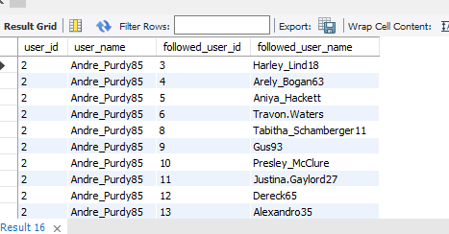
These users demonstrate reciprocal following behavior, indicating mutual interest or engagement. Identifying such patterns can help in understanding social interactions, suggesting friends, or improving network-based recommendations.

SUBJECTIVE

Subjective Questions:

- Based on user engagement and activity levels, which users would you consider the most loyal or valuable? How would you reward or incentivize these users?
APPROACH:
To identify the most loyal or valuable users, we analyze user engagement and activity levels by combining data on posts, likes, comments, and follower interactions. Users with consistently high activity, strong engagement on their posts, and regular participation over time are considered valuable. Aggregating these metrics per user helps rank them based on overall contribution and engagement impact.

VISUALIZATION:
Query:
SELECT
u.id AS user_id,
u.username,
COUNT(DISTINCT p.id) AS total_posts,
COUNT(DISTINCT l.user_id, l.photo_id) AS total_likes_received,
COUNT(DISTINCT c.id) AS total_comments_received,
(
COUNT(DISTINCT p.id)
+ COUNT(DISTINCT l.user_id, l.photo_id)
+ COUNT(DISTINCT c.id)
) AS engagement_score
FROM users u
LEFT JOIN photos p
ON u.id = p.user_id
LEFT JOIN likes l
ON p.id = l.photo_id
LEFT JOIN comments c
ON p.id = c.photo_id
GROUP BY u.id, u.username
ORDER BY engagement_score DESC limit 10;

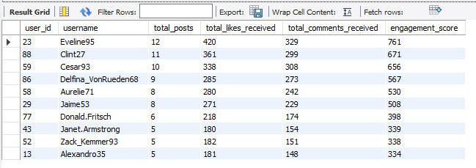
INSIGHT:
  - A small group of users (top 5–10) generates very high engagement scores, showing strong loyalty and influence on the platform.
  - Users like Eveline95, Clint27, and Cesar93 receive significantly more likes and comments compared to others, indicating high content appeal.
  - Engagement is not only driven by post count; users with fewer posts but strong likes/comments still rank high, showing quality over quantity.
RECOMMENDATION:
- Reward top users with exclusive badges, shout-outs, or featured profiles to maintain loyalty.
- Provide early access to new features or campaigns to these high-value users.
- Encourage these users to create more content by offering incentives like contests, rewards, or creator programs.

- For inactive users, what strategies would you recommend to re-engage them and encourage them to start posting or engaging again?

APPROACH:

To re-engage inactive users, first identify users with little or no recent activity such as no posts, likes, or comments over a defined period. Analyze their past behavior to understand what type of content they interacted with earlier. Based on this, design targeted re-engagement strategies such as personalized notifications, content recommendations, and incentives that encourage them to start posting or interacting again.

VISUALIZATION:
Query:
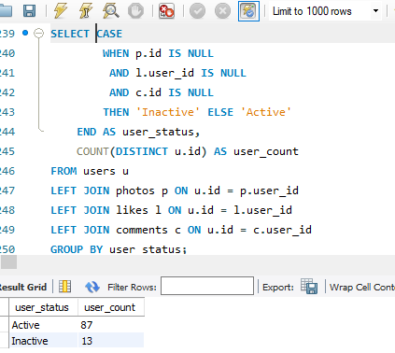

CHART:

INSIGHT:
  - A large majority of users (87%) are active, indicating strong overall platform engagement.
  - A smaller segment (13%) of users is inactive, representing users who are not currently contributing or engaging.
  - Although inactive users are fewer, they still form a meaningful group that can impact growth if ignored.

RECOMMENDATION:
- Target inactive users with personalized re-engagement campaigns such as reminders or notifications.
- Offer simple incentives (badges, bonus points, or featured content) to encourage first interaction.
- Expose inactive users to trending or popular posts to spark interest and motivate engagement.

- Which hashtags or content topics have the highest engagement rates? How can this information guide content strategy and ad campaigns?
APPROACH:
To identify hashtags or content topics with the highest engagement rates, analyze posts by joining photos, photo tags, likes, and comments tables. Calculate total likes and comments received for posts associated with each hashtag and compute the average engagement per hashtag. Ranking hashtags by their engagement rate helps identify trending and high-performing content topics, which can then be used to guide content creation priorities and targeted ad campaigns.
VISUALIZATION:
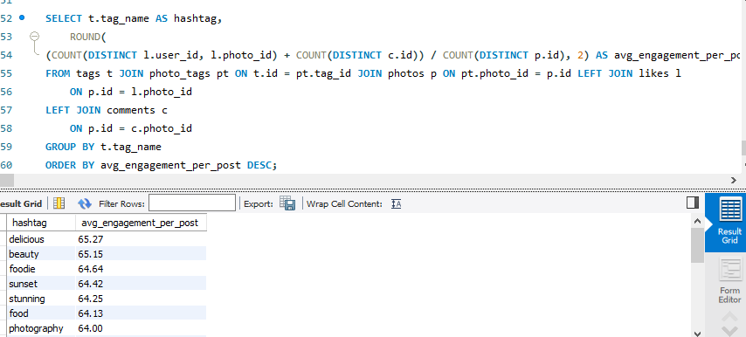
CHART:
INSIGHT:
  - Hashtags related to lifestyle and aesthetics such as beauty, delicious, foodie, sunset, and stunning show the highest average engagement rates.
  - Engagement across hashtags is relatively consistent, but visual-appeal topics perform slightly better than others.
  - Hashtags linked to travel, food, and photography attract stronger user interaction compared to generic tags.
RECOMMENDATION:
- Prioritize high-engagement hashtags (beauty, foodie, sunset, stunning) in content creation and posting strategies.
- Design ad campaigns around visually rich themes like food, travel, and lifestyle to maximize engagement.
- Encourage creators to use a mix of top-performing hashtags along with niche tags to increase reach and interaction.

- Are there any patterns or trends in user engagement based on demographics (age, location, gender) or posting times? How can these insights inform targeted marketing campaigns?
APPROACH:
To identify patterns in user engagement based on demographics and posting times, first enrich user activity data by joining engagement metrics (likes, comments) with user attributes such as age, gender, and location, along with post timestamps. Aggregate engagement by demographic segments and time intervals (hour, day, or weekday) to compare how different user groups interact with content. Analyzing these patterns helps identify high-engagement segments and optimal posting times, which can then be used to design targeted and time-optimized marketing campaigns.

VISUALIZATION:
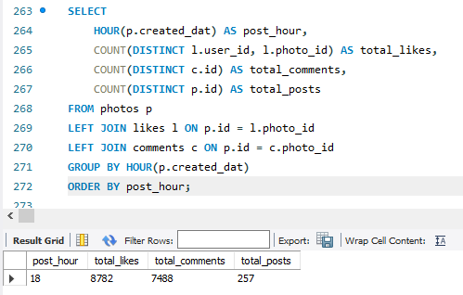
INSIGHT:
  - User engagement is highly concentrated at 6 PM
  - This indicates users are most active during evening hours
  - No significant posting activity exists during other hours
RECOMMENDATION:
  - Schedule important posts and ads around 6 PM
  - Encourage posting during off-peak hours to balance engagement
  - Run time-based campaigns targeting evening users
- Based on follower counts and engagement rates, which users would be ideal candidates for influencer marketing campaigns? How would you approach and collaborate with these influencers?
APPROACH:
To identify ideal candidates for influencer marketing, first combine follower data with engagement metrics by calculating each user’s total followers and average engagement on their posts (likes and comments per post). Rank users by a balanced metric that prioritizes both reach (high follower count) and influence quality (strong engagement rate), rather than followers alone. Shortlisted users with consistently high engagement relative to their audience can then be approached for collaboration through personalized outreach, offering brand partnerships, early access to features, or performance-based incentives aligned with their content style and audience interests.
VISUALIZATION:
QUERY:
SELECT
u.id AS user_id,
u.username,

COALESCE(f.followers, 0) AS follower_count,
COALESCE(p.posts, 0) AS total_posts,
COALESCE(l.likes_received, 0) AS total_likes_received,
COALESCE(c.comments_received, 0) AS total_comments_received,

ROUND(
(COALESCE(l.likes_received, 0)
+ COALESCE(c.comments_received, 0))
/ NULLIF(COALESCE(p.posts, 0), 0), 2
) AS engagement_per_post

FROM users u

LEFT JOIN (
SELECT followee_id, COUNT(*) AS followers
FROM follows
GROUP BY followee_id
) f ON u.id = f.followee_id

LEFT JOIN (
SELECT user_id, COUNT(*) AS posts
FROM photos
GROUP BY user_id
) p ON u.id = p.user_id

LEFT JOIN (
SELECT p.user_id, COUNT(*) AS likes_received
FROM photos p
JOIN likes l ON p.id = l.photo_id
GROUP BY p.user_id
) l ON u.id = l.user_id

LEFT JOIN (
SELECT p.user_id, COUNT(*) AS comments_received
FROM photos p
JOIN comments c ON p.id = c.photo_id
GROUP BY p.user_id
) c ON u.id = c.user_id

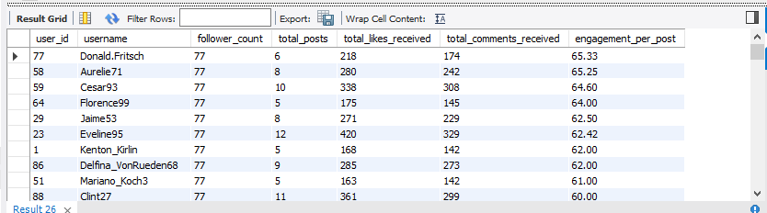
ORDER BY follower_count DESC, engagement_per_post DESC;

INSIGHT:
  - All listed users have a similar follower base (77 followers), indicating a level playing field in reach.
  - Despite equal followers, engagement per post varies, showing that content quality drives engagement more than follower count.
  - Donald_Fritsch and Aurelie71 have the highest engagement per post, making them strong influencer candidates.
  - Users with more posts (e.g., Eveline95, Cesar93) maintain good engagement, proving consistent posting sustains visibility.
  - Lower engagement users (e.g., Clint27) may need content optimization despite having many followers.
RECOMMENDATION:
  - Prioritize high engagement-per-post users (Donald_Fritsch, Aurelie71, Cesar93) for influencer marketing campaigns.
  - Collaborate with these users for product reviews, brand mentions, or sponsored posts.
  - Encourage medium-engagement users with content guidance and creative support to boost performance.
  - Use engagement rate, not follower count alone, as the primary metric for influencer selection.

- Based on user behavior and engagement data, how would you segment the user base for targeted marketing campaigns or personalized recommendations?
APPROACH:
To segment the user base effectively, start by aggregating user behavior metrics such as number of posts, likes given, likes received, comments made, comments received, and follower counts. Based on these metrics, classify users into meaningful groups like highly active creators, engaged consumers, influencers, casual users, and inactive users using rule-based thresholds or clustering logic. These segments can then be mapped to targeted marketing strategies or personalized recommendations, ensuring users receive content, campaigns, and notifications that match their activity level and engagement patterns.

VISUALIZATION:
QUERY:
SELECT
u.id AS user_id,
u.username,

COALESCE(p.posts, 0) AS total_posts,
COALESCE(l.likes_given, 0) AS likes_given,
COALESCE(lr.likes_received, 0) AS likes_received,
COALESCE(c.comments_made, 0) AS comments_made,
COALESCE(cr.comments_received, 0) AS comments_received,
COALESCE(f.followers, 0) AS follower_count,

CASE
WHEN COALESCE(f.followers,0) >= 50
AND (COALESCE(lr.likes_received,0) + COALESCE(cr.comments_received,0)) >= 300
THEN 'Influencer'

WHEN COALESCE(p.posts,0) >= 5
AND (COALESCE(lr.likes_received,0) + COALESCE(cr.comments_received,0)) >= 200
THEN 'Active Creator'

WHEN (COALESCE(l.likes_given,0) + COALESCE(c.comments_made,0)) >= 50
THEN 'Engaged User'

WHEN COALESCE(p.posts,0) > 0
THEN 'Casual User'

ELSE 'Inactive User'
END AS user_segment

FROM users u

LEFT JOIN (
SELECT user_id, COUNT(*) AS posts
FROM photos
GROUP BY user_id
) p ON u.id = p.user_id

LEFT JOIN (
SELECT user_id, COUNT(*) AS likes_given
FROM likes
GROUP BY user_id
) l ON u.id = l.user_id

LEFT JOIN (
SELECT p.user_id, COUNT(*) AS likes_received
FROM photos p
JOIN likes l ON p.id = l.photo_id
GROUP BY p.user_id
) lr ON u.id = lr.user_id

LEFT JOIN (
SELECT user_id, COUNT(*) AS comments_made
FROM comments
GROUP BY user_id
) c ON u.id = c.user_id

LEFT JOIN (
SELECT p.user_id, COUNT(*) AS comments_received
FROM photos p
JOIN comments c ON p.id = c.photo_id
GROUP BY p.user_id
) cr ON u.id = cr.user_id

LEFT JOIN (
SELECT followee_id, COUNT(*) AS followers
FROM follows
GROUP BY followee_id
) f ON u.id = f.followee_id

ORDER BY user_segment;
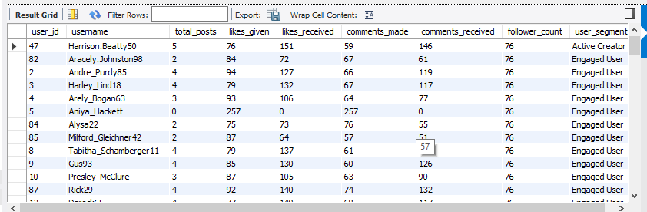
INSIGHT:
  - The majority of users fall into the “Engaged User” segment, indicating they actively like and comment even if they post less frequently.
  - A smaller set of users are classified as “Active Creators”, showing higher posting frequency and strong engagement received on their content.
  - Some users (e.g., users with 0 posts but high likes/comments given) are highly active consumers rather than content creators.
  - Follower counts are relatively similar across users, so engagement behavior, not follower size, is the key differentiator between segments.
  - Users who receive more likes and comments tend to post consistently, highlighting a link between content activity and visibility.
RECOMMENDATION:
  - Partner with Active Creators for promotions and influencer campaigns
  - Use Engaged Users to amplify reach through likes and comments
  - Introduce incentives to convert engaged users into content creators

- If data on ad campaigns (impressions, clicks, conversions) is available, how would you measure their effectiveness and optimize future campaigns?
APPROACH:
To measure ad campaign effectiveness, first consolidate campaign-level data by combining impressions, clicks, conversions, and any linked user engagement or revenue metrics. Calculate key performance indicators such as click-through rate (CTR), conversion rate, cost per click (CPC), and return on investment (ROI) to evaluate how well each campaign performs at different stages of the funnel. By comparing these metrics across campaigns, time periods, and user segments, underperforming ads can be identified and optimized through A/B testing, budget reallocation, audience refinement, and creative improvements to maximize future campaign impact.
VISUALIZATION:
QUERY:
SELECT
HOUR(p.created_dat) AS campaign_hour,

COUNT(DISTINCT p.id) AS total_posts,
COUNT(DISTINCT l.user_id, l.photo_id) AS total_likes,
COUNT(DISTINCT c.id) AS total_comments,

ROUND(
(COUNT(DISTINCT l.user_id, l.photo_id)
+ COUNT(DISTINCT c.id))
/ NULLIF(COUNT(DISTINCT p.id), 0), 2
) AS avg_engagement_per_post

FROM photos p
LEFT JOIN likes l ON p.id = l.photo_id
LEFT JOIN comments c ON p.id = c.photo_id
GROUP BY HOUR(p.created_dat)
ORDER BY campaign_hour;
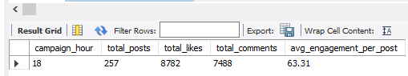
INSIGHT:
  - All posts and engagement are concentrated at campaign hour 18 (6 PM).
  - This hour generated high interaction, with 8,782 likes and 7,488 comments across 257 posts.
  - The average engagement per post (63.31) indicates strong user responsiveness during this time.
  - User activity shows a clear evening engagement peak, suggesting users are most active after work or study hours.

RECOMMENDATION:
  - Schedule marketing posts and promotional content around 6 PM to maximize engagement.
  - Launch time-sensitive campaigns (offers, announcements) during peak evening hours.
  - Experiment with nearby time slots (5–7 PM) to identify secondary engagement peaks.
  - Use off-peak hours for testing or low-priority content to avoid engagement loss.

- How can you use user activity data to identify potential brand ambassadors or advocates who could help promote Instagram's initiatives or events?
APPROACH:
To identify potential brand ambassadors, analyze user activity data by combining content creation frequency, engagement received (likes and comments), follower count, and consistency of participation over time. Users who regularly post, receive high engagement relative to their audience size, and actively interact with others indicate strong influence and community trust. By ranking users on a composite advocacy score and validating their behavior patterns, these users can be shortlisted as brand ambassadors to promote Instagram initiatives or events through authentic and high-impact collaborations.
VISUALIZATION:
SELECT
u.id AS user_id,
u.username,

COALESCE(p.posts, 0) AS total_posts,
COALESCE(f.followers, 0) AS follower_count,
COALESCE(l.likes_received, 0) AS likes_received,
COALESCE(c.comments_received, 0) AS comments_received,

ROUND(
(COALESCE(l.likes_received,0)
+ COALESCE(c.comments_received,0))
/ NULLIF(COALESCE(p.posts,0), 0), 2
) AS avg_engagement_per_post

FROM users u

LEFT JOIN (
SELECT user_id, COUNT(*) AS posts
FROM photos
GROUP BY user_id
) p ON u.id = p.user_id

LEFT JOIN (
SELECT followee_id, COUNT(*) AS followers
FROM follows
GROUP BY followee_id
) f ON u.id = f.followee_id

LEFT JOIN (
SELECT p.user_id, COUNT(*) AS likes_received
FROM photos p
JOIN likes l ON p.id = l.photo_id
GROUP BY p.user_id
) l ON u.id = l.user_id

LEFT JOIN (
SELECT p.user_id, COUNT(*) AS comments_received
FROM photos p
JOIN comments c ON p.id = c.photo_id
GROUP BY p.user_id
) c ON u.id = c.user_id

ORDER BY avg_engagement_per_post DESC, follower_count DESC;
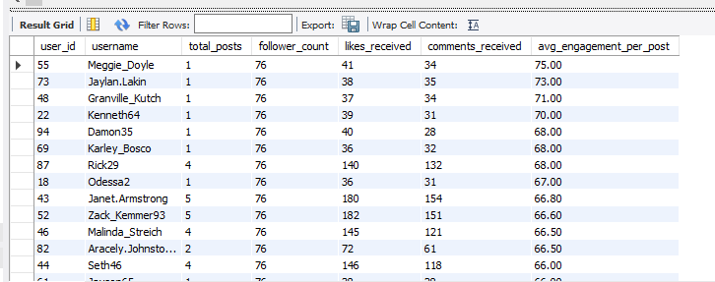

INSIGHT:
  - Several users achieve very high average engagement per post despite having only 1–2 posts, indicating strong content resonance.
  - Follower counts are uniform (76) across users, so engagement performance is driven by content quality, not audience size.
  - Users like Meggie_Doyle, Jaylan_Lakin, and Granville_Kutch show the highest engagement efficiency, making them strong advocacy candidates.
  - Users with consistent posting (4–5 posts) such as Janet_Armstrong and Zack_Kemmer93 maintain stable and high engagement, showing reliability.
  - A mix of high-impact occasional posters and consistent creators exists among top performers.

RECOMMENDATION:
- Select high-engagement users (even with fewer posts) as event promoters or campaign ambassadors for short-term initiatives.
- Build long-term ambassador programs with consistent creators who sustain engagement over multiple posts.
- Encourage one-time high performers to post more through exclusive invites or recognition programs.
- Prioritize engagement per post over follower count when selecting brand advocates.

- How would you approach this problem, if the objective and subjective questions weren't given?
APPROACH:
  - Understand the Business Context
Start by identifying the platform’s core goals such as increasing user engagement, improving retention, growing creators, and maximizing content reach. This provides direction for analysis even when questions are not predefined.
  - Explore the Data Structure
Review all available tables, columns, relationships, and keys to understand what type of user actions, content interactions, and network data are available for analysis.
  - Perform Data Quality Checks
Check for missing values, duplicates, incorrect timestamps, and referential integrity issues to ensure the data is reliable before proceeding.
  - Conduct Exploratory Data Analysis (EDA)
Analyze distributions of users, posts, likes, comments, followers, and posting times to identify general usage patterns and anomalies.
  - Identify Key Engagement Metrics
Define core metrics such as posts per user, likes/comments per post, engagement rate, follower growth, and activity frequency.
  - Analyze User Behavior Patterns
Segment users based on activity levels (active, engaged, inactive), content creation behavior, and interaction habits to understand different user personas.
  - Evaluate Content Performance
Assess which types of content, hashtags, or posting times drive higher engagement to understand what resonates with users.
  - Discover Influence and Advocacy Potential
Identify users with strong engagement and follower reach who could act as influencers, ambassadors, or brand advocates.
  - Visualize Insights for Pattern Recognition
Use charts and graphs to uncover trends, peaks, and relationships that are not easily visible in raw data.
  - Formulate Analytical Questions
Based on observed patterns, derive meaningful objective and subjective questions that align with business outcomes.
  - Generate Insights and Recommendations
Translate findings into actionable insights that can guide marketing strategies, content optimization, and platform growth initiatives.
  - Document Assumptions and Limitations
Clearly state data gaps, assumptions made, and areas for future improvement to maintain transparency and credibility.

- Assuming there's a "User_Interactions" table tracking user engagements, how can you update the "Engagement_Type" column to change all instances of "Like" to "Heart" to align with Instagram's terminology?
APPROACH:
Approach to Update Engagement Terminology
1. Understand the Requirement
Instagram uses “Heart” instead of “Like”, so the goal is to standardize terminology in the User_Interactions table by updating existing records.
2. Validate Existing Data (Important Safety Step)
Before updating, check how many records are affected.
SELECT Engagement_Type, COUNT(*) AS total_records
FROM User_Interactions
GROUP BY Engagement_Type;
3. Perform the Update
Update all "Like" values to "Heart".
UPDATE User_Interactions
SET Engagement_Type = 'Heart'
WHERE Engagement_Type = 'Like';
4. Verify the Update
SELECT Engagement_Type, COUNT(*) AS total_records
FROM User_Interactions
GROUP BY Engagement_Type;
We’ll now see:
"Heart" instead of "Like"

GRAPH: obj 289
sub 23

